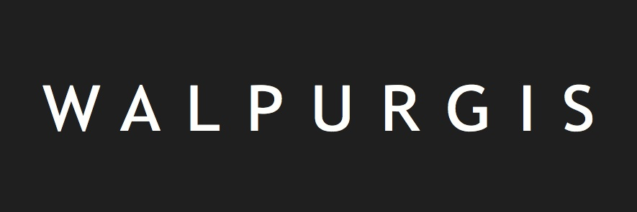
APPLICATION FORM
Residency as part of the FENIKS FESTIVAL 2017
Theme: transition
Genre: music theatre

Please submit no more than 1 application form per project.

PERSONAL DETAILS (contact):

NAME:
FIRST NAME:

GENDER:
DATE OF BIRTH:
NATIONALITY:

ADDRESS:
CITY:
POST CODE:
COUNTRY:

PHONE:
MOBILE:
MAIL ADDRESS:
SKYPE ADDRESS:

PROJECT DETAILS

NAME OF COMPANY/COLLECTIVE (if applicable):
NUMBER OF PARTICIPANTS IN THE RESIDENCY:
WEBSITE:
FACEBOOK:

TICK THE DISCIPLINE(S) APPLICABLE TO YOU PROJECT (multiple answers possible):
- Visual arts
- Music
- Film & video
- Architecture
- Theatre
- Literature
- Dance
- Photography
- Other: …………
(WORKING) TITLE OF THE PROJECT:

A SHORT, ENGAGING DESCRIPTION OF THE PROJECT FOR PUBLICATION IN THE FESTIVAL BROCHURE (max. 1 sentence)

DETAILED DESCRIPTION OF THE PROJECT:

IN WHAT WAY IS YOUR PROJECT RELATED TO THE MUSIC-THEATRE GENRE?

HOW DOES YOUR PROJECT FIT INTO THE THEME OF TRANSITION?

DOES YOUR PROJECT ALREADY RECEIVE SUPPORT? IF APPLICABLE, DESCRIBE PREVIOUS COOPERATION IN THE CONTEXT OF THE PROPOSED PROJECT.

EXPLAIN IN DETAIL WHY YOU ARE APPLYING FOR A RESIDENCE:

WHAT DO YOU WISH TO ACHIEVE DURING YOUR RESIDENCE AT deFENIKS? (Describe the steps you want to take and also indicate the timing of this process):

WHAT IS THE IDEAL LOCATION AND WHAT ARE THE TECHNICAL REQUIREMENTS FOR YOUR PROJECT?
(Look at the technical possibilities of the spaces at deFENIKS and consult the technical specifications).

CONCISE CV OF THE PARTICIPANT(S):

REFERENCES (website, YouTube, Facebook, artwork, Soundcloud, Tumblr, Flickr, Instagram, Vimeo, Blog, etc. Make sure the links you send remain active until at least one month after the application deadline).

PRACTICAL INFORMATION

HOW DID YOU FIND OUT ABOUT THE RESIDENCE PROGRAMME?

PLEASE INDICATE YOUR PREFERRED RESIDENCE PERIODS:
(The FENIKS FESTIVAL is on from 21 to 24 September 2017)

Period 1: from … /… /2017 to … /… /2017
Period 2 (alternative choice): from … /… 2017 to … /… /2017

